FOLH1 Comparison Across Cancer Types
The whole TCGA pan data was used in order to compare which cancers showed the highest expression of FOLH1 (PSMA) in their primary tumor samples. The counts were normalized and divided according to which cancer type they are from and compared using bagplots, dot blots and boxplots, which were based on the top 10 cancer types.

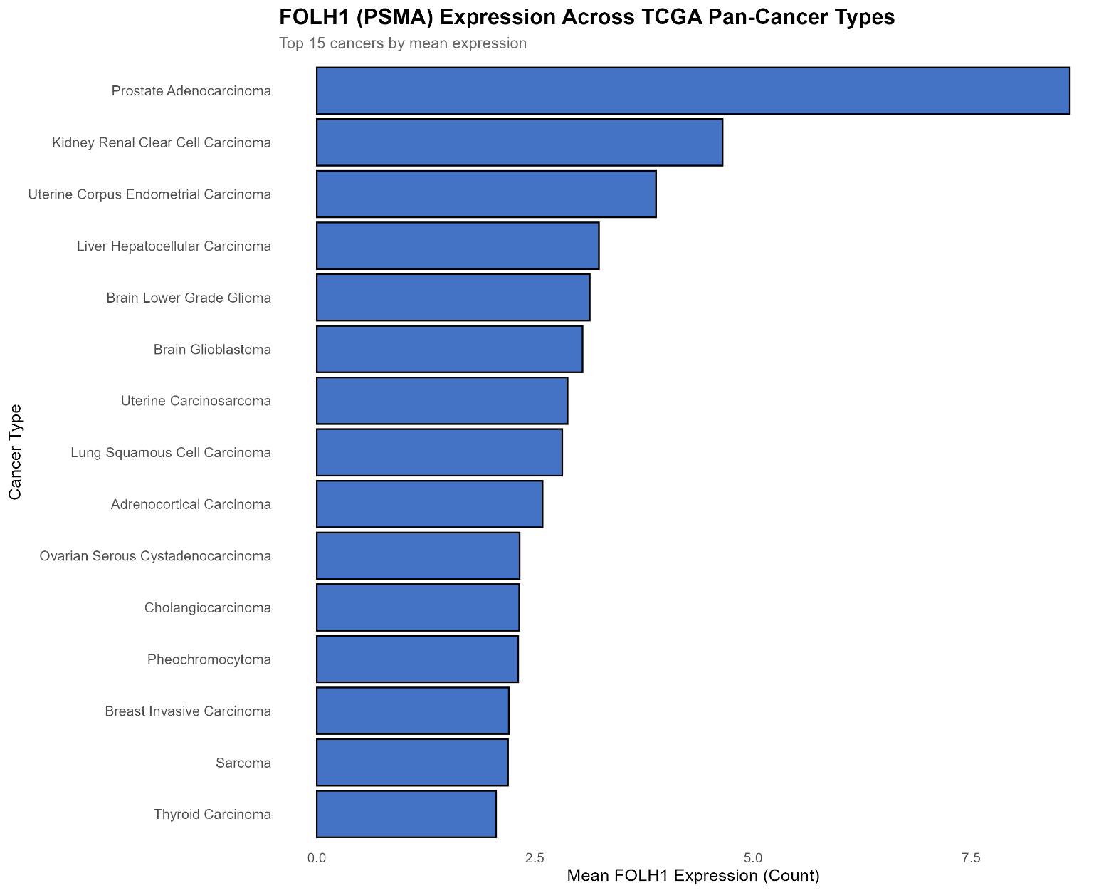
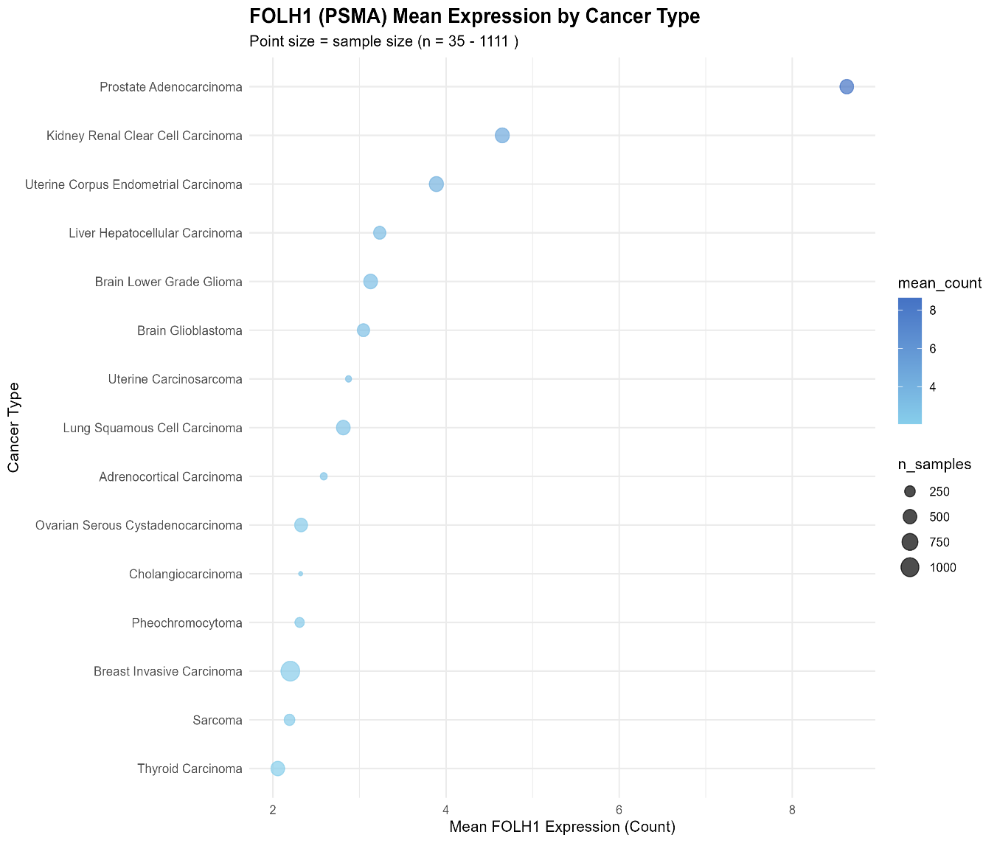
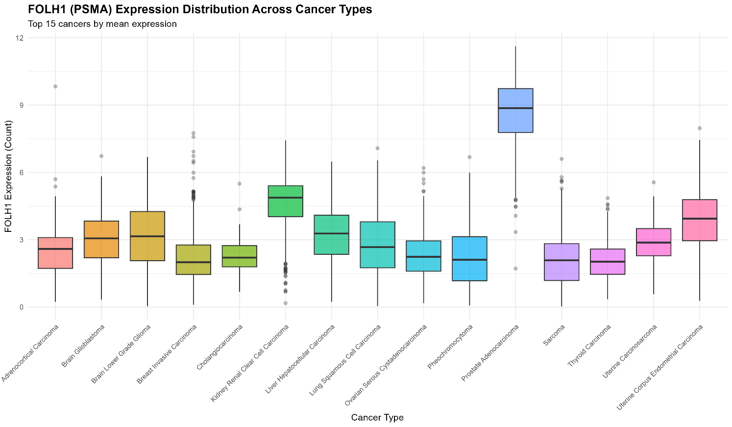

Summarized Table Of All Cancers
Cancer type | mean count | median count | sd count | n samples
Prostate Adenocarcinoma | 8.629697 | 8.863197 | 1.467995 | 501
Kidney Renal Clear Cell Carcinoma | 4.650024 | 4.874015 | 1.222779 | 541
Uterine Corpus Endometrial Carcinoma | 3.888356 | 3.939326 | 1.327679 | 553
Liver Hepatocellular Carcinoma | 3.233556 | 3.278925 | 1.224903 | 371
Brain Lower Grade Glioma | 3.128531 | 3.151962 | 1.498207 | 516
Brain Glioblastoma | 3.04558 | 3.062148 | 1.118898 | 372
Uterine Carcinosarcoma | 2.87355 | 2.873856 | 1.055883 | 57
Lung Squamous Cell Carcinoma | 2.812927 | 2.671026 | 1.37954 | 511
Adrenocortical Carcinoma | 2.58724 | 2.592032 | 1.453717 | 78
Ovarian Serous Cystadenocarcinoma | 2.325284 | 2.241145 | 1.036699 | 426
Cholangiocarcinoma | 2.319912 | 2.205751 | 0.941862 | 35
Pheochromocytoma | 2.308288 | 2.108956 | 1.397463 | 179
Breast Invasive Carcinoma | 2.200967 | 1.998452 | 1.038849 | 1111
Sarcoma | 2.191409 | 2.083418 | 1.265246 | 257
Thyroid Carcinoma | 2.056028 | 2.025067 | 0.830851 | 505
Kidney Chromophobe | 1.979217 | 1.950335 | 0.830156 | 66
Pancreatic Adenocarcinoma | 1.961413 | 1.771622 | 1.13908 | 178
Oesophageal Carcinoma | 1.958613 | 1.74367 | 1.101464 | 184
Lung Adenocarcinoma | 1.934801 | 1.832244 | 0.928701 | 540
Stomach Adenocarcinoma | 1.820369 | 1.559572 | 1.119617 | 412
Head and Neck Squamous Cell Carcinoma | 1.814945 | 1.597906 | 1.104389 | 520
Bladder Urothelial Carcinoma | 1.688495 | 1.544934 | 0.902358 | 412
Testicular Germ Cell Tumours | 1.569918 | 1.225711 | 1.0986 | 150
Skin Cutaneous Melanoma | 1.481271 | 1.093571 | 1.324355 | 103
Mesothelioma | 1.461495 | 1.285904 | 0.82483 | 87
Colon Adenocarcinoma | 1.409011 | 1.335103 | 0.745293 | 478
Cervical Squamous Cell Carcinoma | 1.398421 | 1.167083 | 0.96662 | 304
Rectal Adenocarcinoma | 1.353943 | 1.249737 | 0.642656 | 166
Kidney Renal Papillary Cell Carcinoma | 1.229517 | 0.945586 | 1.030941 | 289
Uveal Melanoma | 0.958714 | 0.900625 | 0.463377 | 80
Thymoma | 0.935048 | 0.613784 | 0.839695 | 116
Diffuse Large B-cell Lymphoma | 0.624576 | 0.55131 | 0.424716 | 48

